Identify The Zones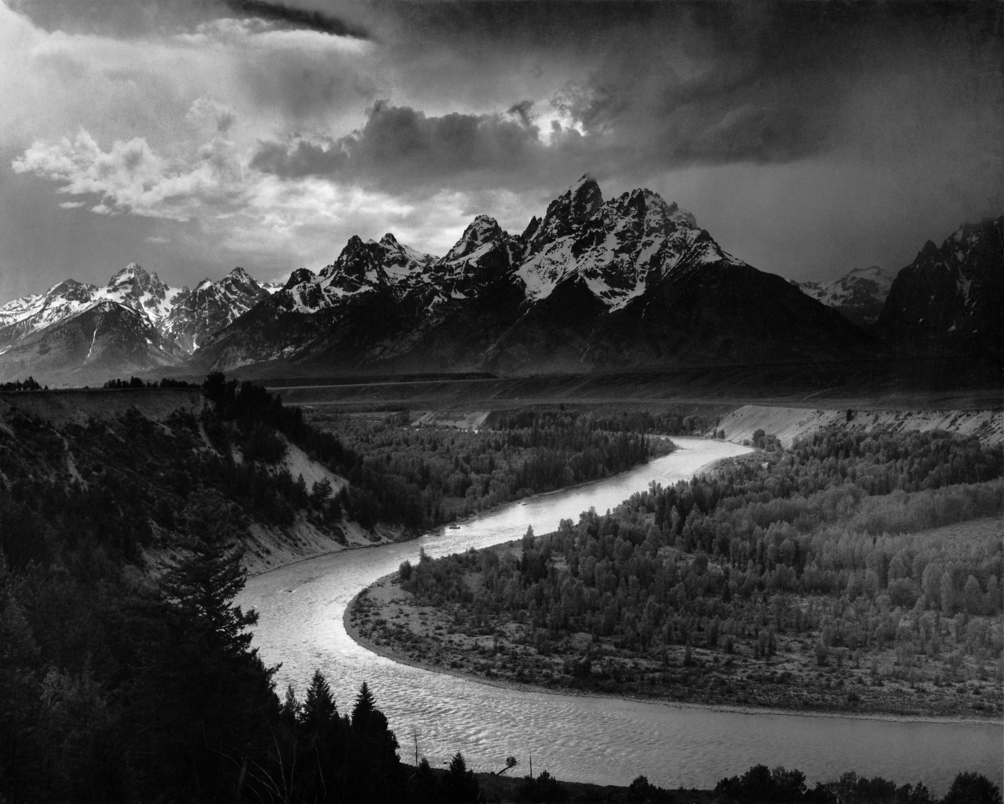Chart:  Shades of Grey