Documentary Photography
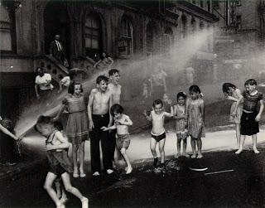
“Documentary photographs are thought of as those in which events in front of the lens (or in the print) have been altered as little as possible from what they would have been, had the photographer not been there….”
–Joan Fontcuberta
What: The importance to documentary photography is to always keep the truth in mind. This means that there will be no alterations done to the photographs. This project can be completed in either digital or film. When taking pictures you need to still be thinking about the elements and principles of design. Your images should also be one central idea around a group/place. When choosing your subject you should think about picking something you have a lot of interest in and have access to.
Your Role: As a documentary photographer your role is to be a witness and record your chosen subject so that viewers are able to gain a sense of all aspects of this subject. To gain a sense of these aspects you should be photographing a lot so that you can narrow your final images down to the best to communicate these aspects.
Requirements: Students will need to turn in 3 photographs no smaller than 8x10. These photos need to give the viewers an insight to the subject you chose to photograph and be a cohesive body. You will also need to turn in a contact sheet and an artist statement along with your 3 photographs. Remember: You will only be able to alter, contrast, value, and slight color correction. YOU MAY NOT: crop, pose, series alterations.
Photographers to Research: Robert Frank, Dorthea Lange, Mary Ellen Mark, James Natchwey, Jim Goldberg, Dave Anderson, Danny Lyon, Walker Evans.
Due Dates:
Work in Progress: January 20th
Final Images and Critique: January 28th at the beginning of class

